**Python Programming and Databricks  
  
Objective**

To explore and practice essential Python programming concepts and Databricks functionalities through hands-on exercises.

#### **Tasks**

1. **FOR Loop**
   * Iterate through a list and print elements.

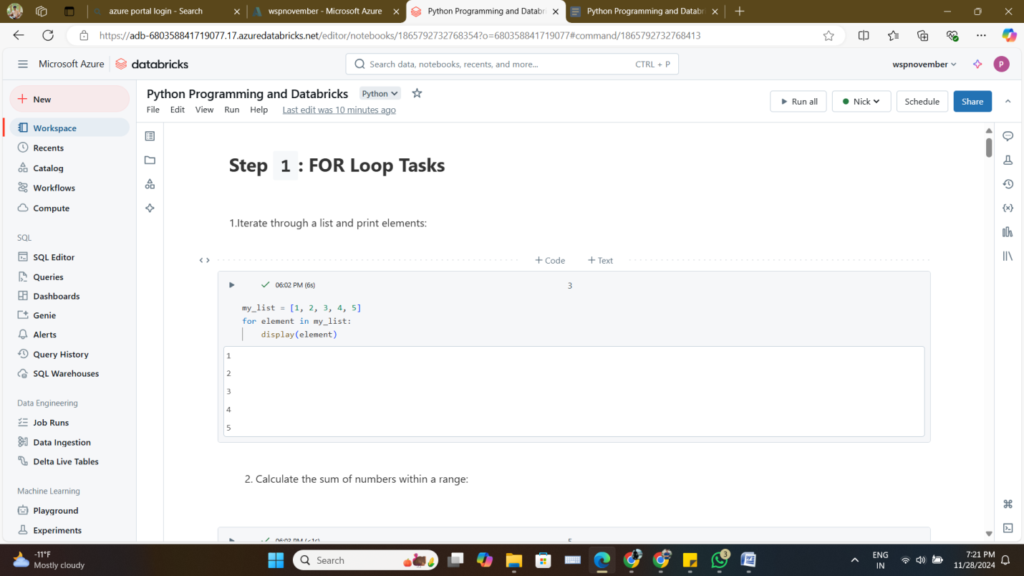

* + Calculate the sum of numbers within a range.

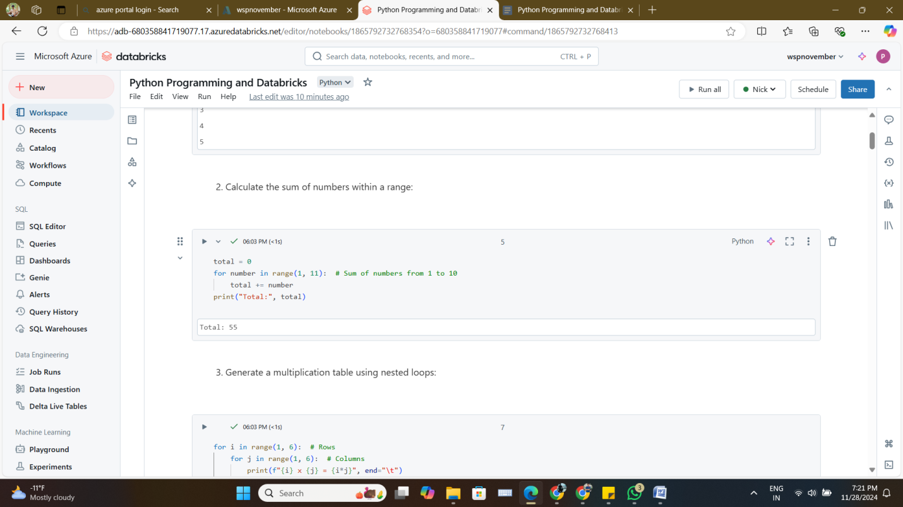

* + Generate a multiplication table using nested loops.

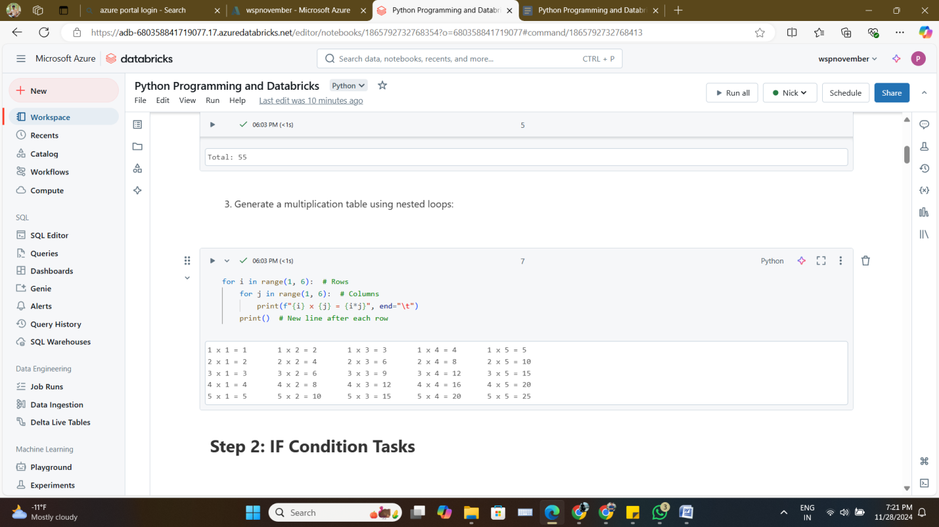

1. **IF Condition**
   * Check if a number is positive, negative, or zero.

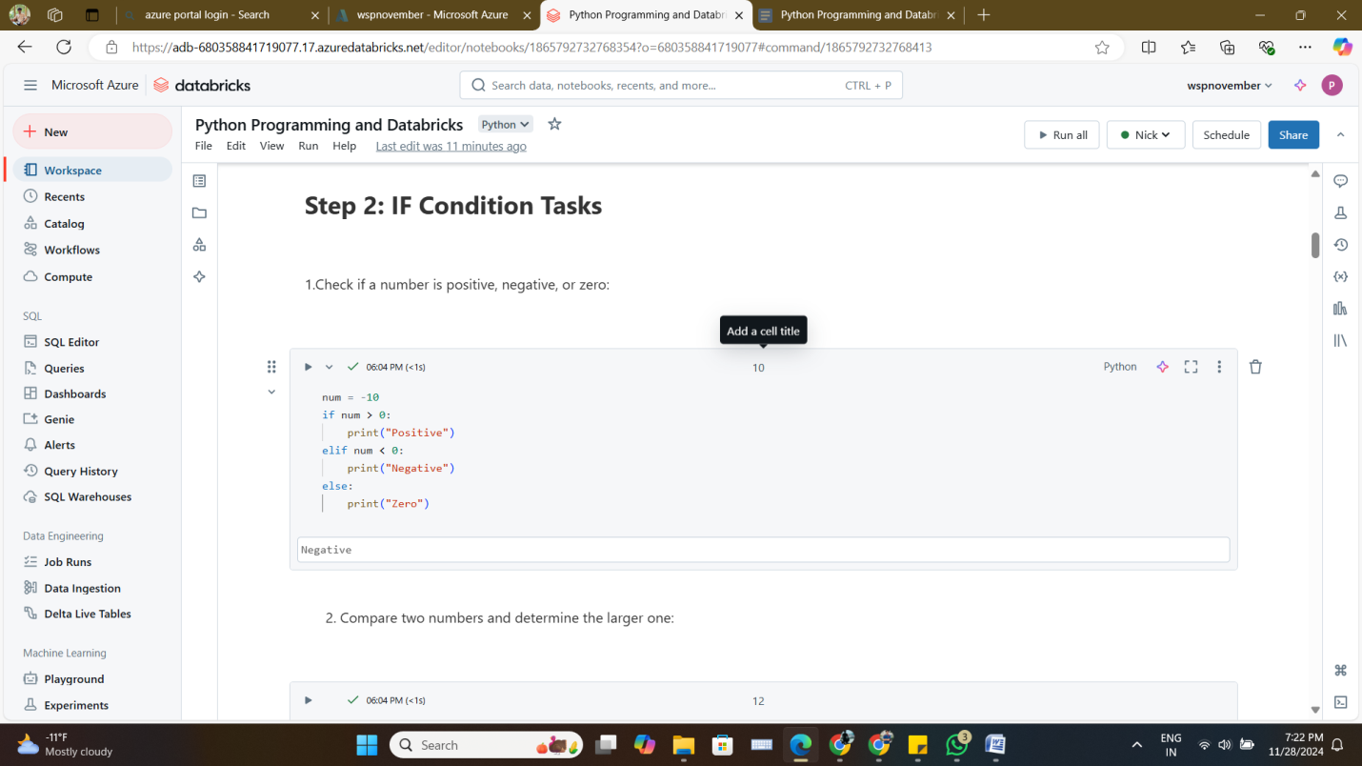

* + Compare two numbers and determine the larger one.

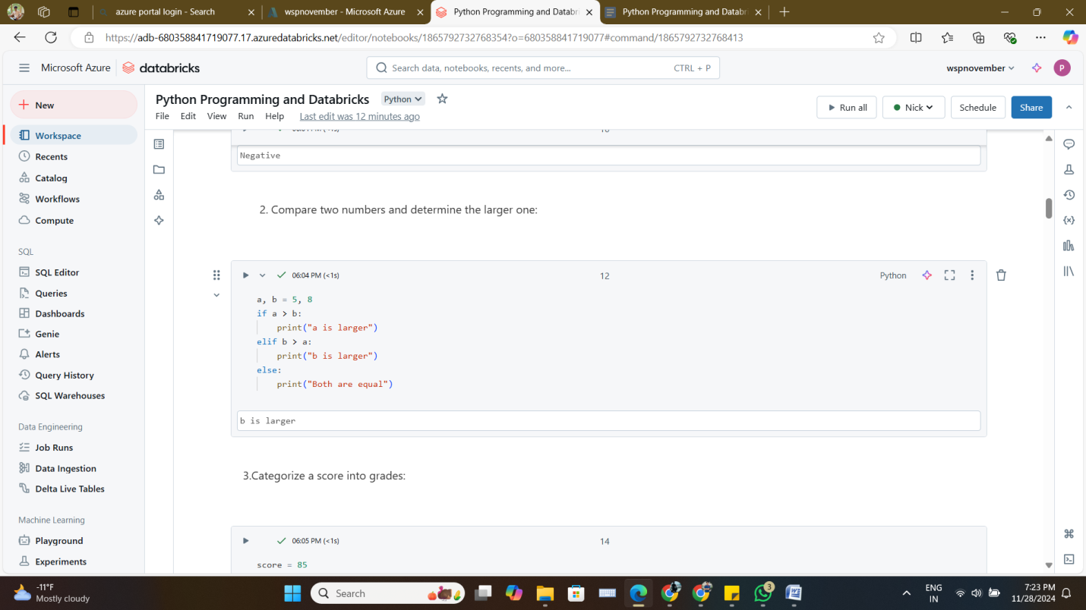

* + Categorize a score into grades using conditional statements.

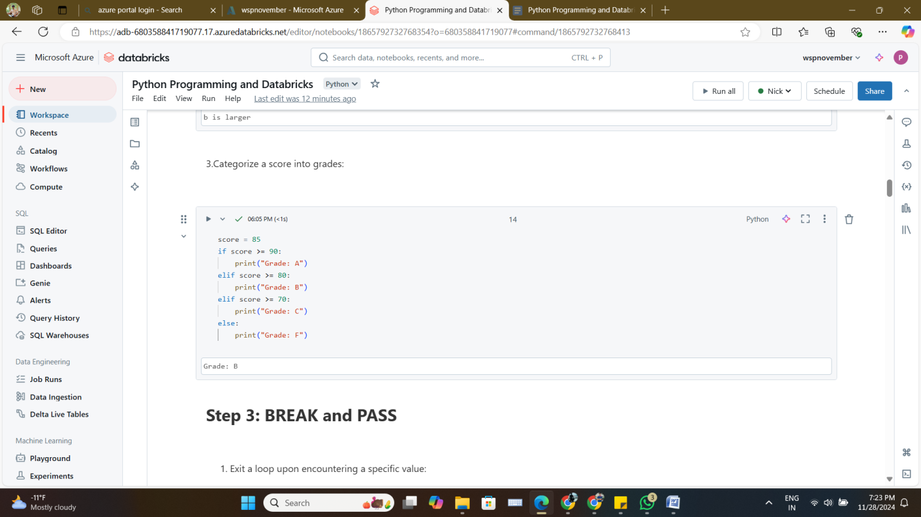

1. **BREAK and PASS**
   * Exit a loop upon encountering a specific value.

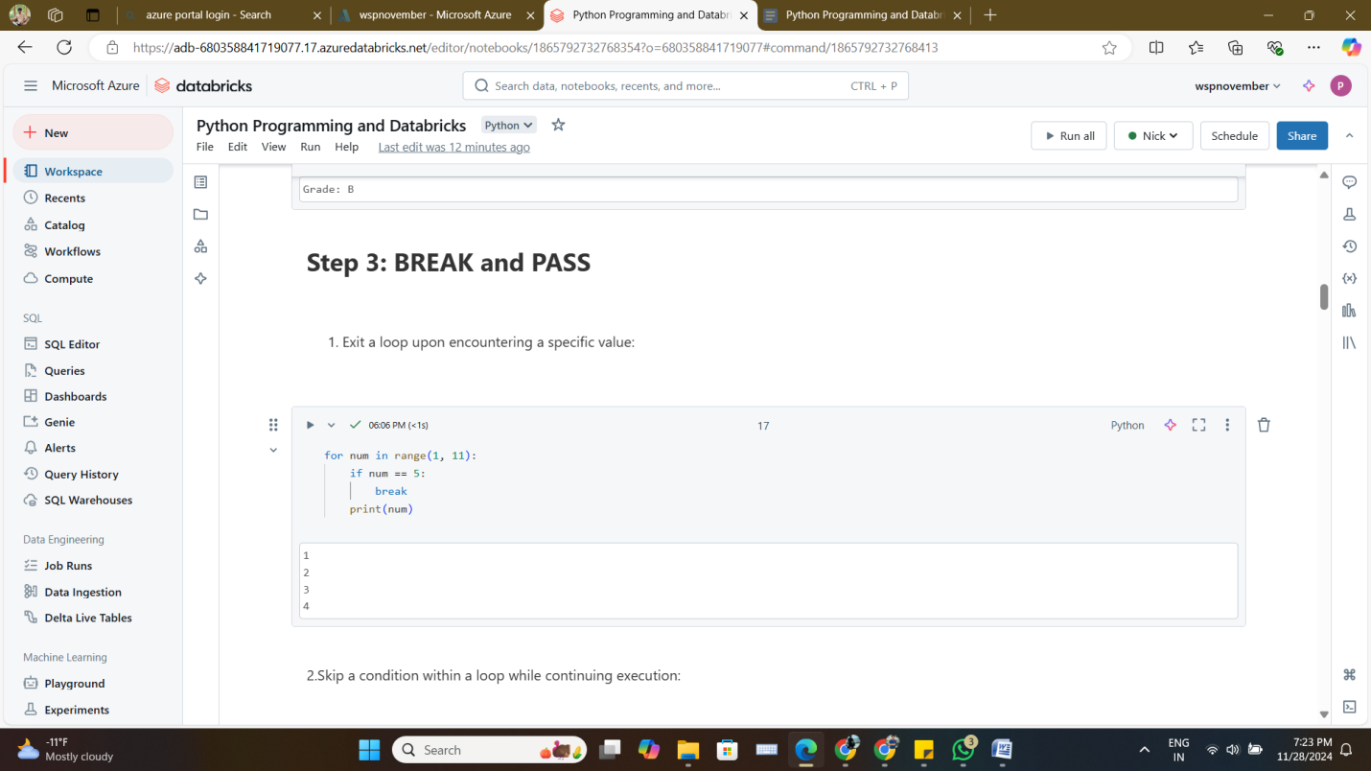

* + Skip a condition within a loop while continuing execution.

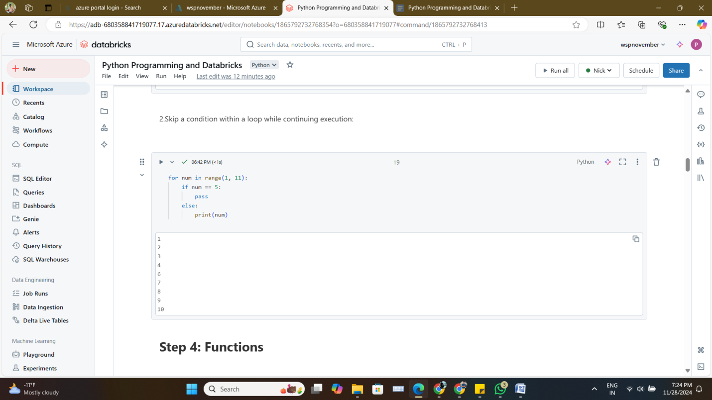

* + Combine BREAK and PASS for advanced loop control.

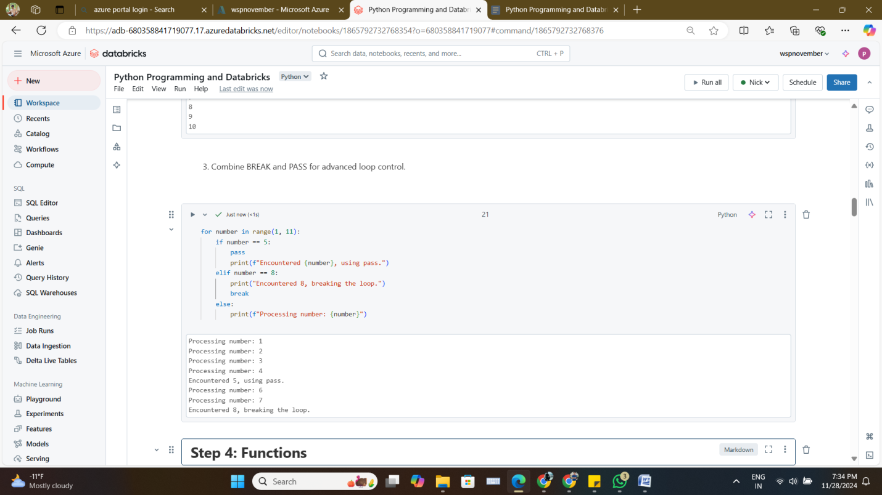

1. **Functions**
   * Write a function to calculate the factorial of a number.

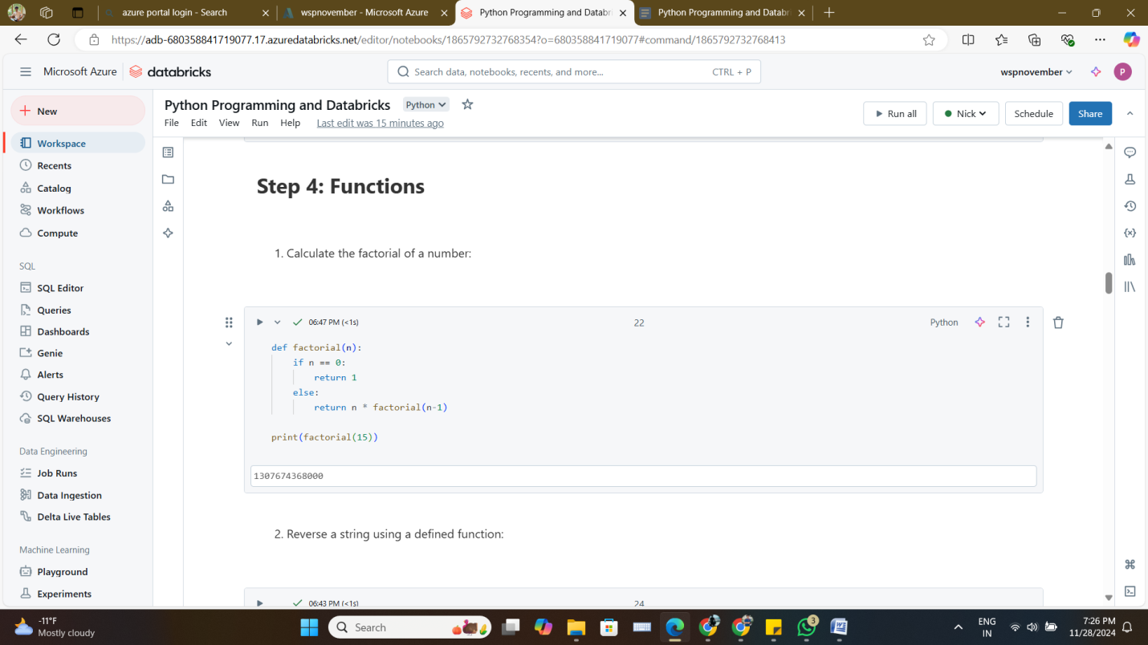

* + Reverse a string using a defined function.

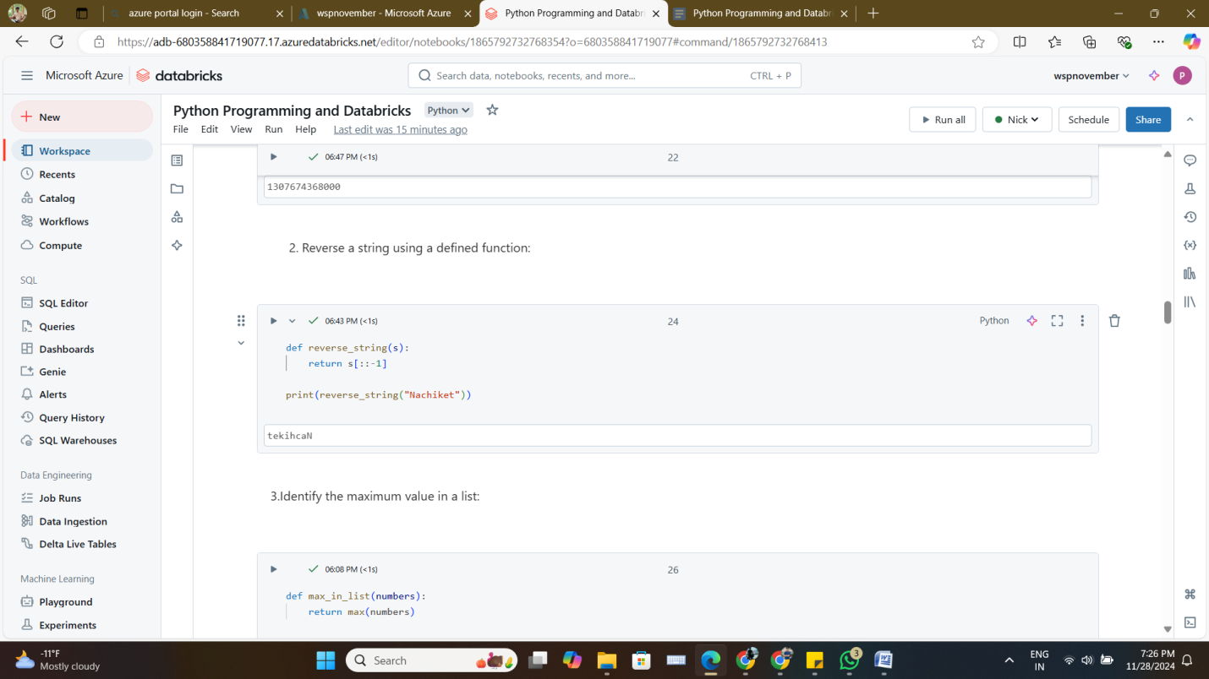

* + Identify the maximum value in a list through a function.

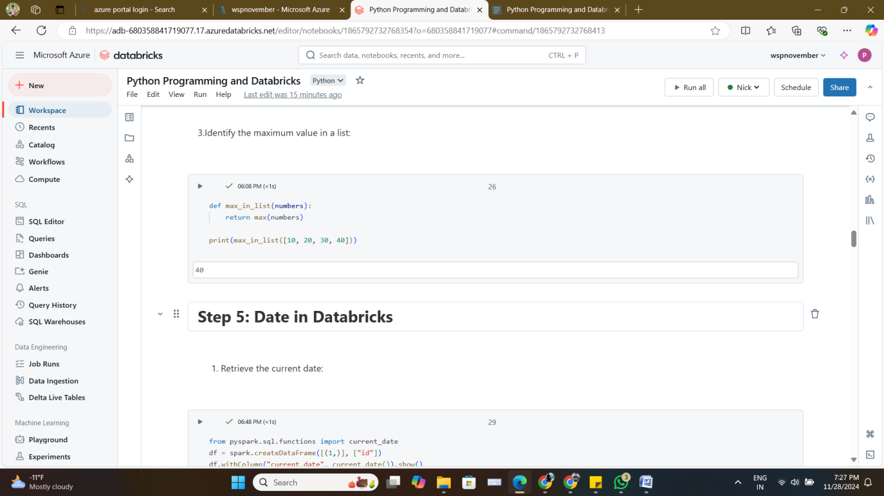

1. **Date in Databricks**
   * Retrieve the current date.

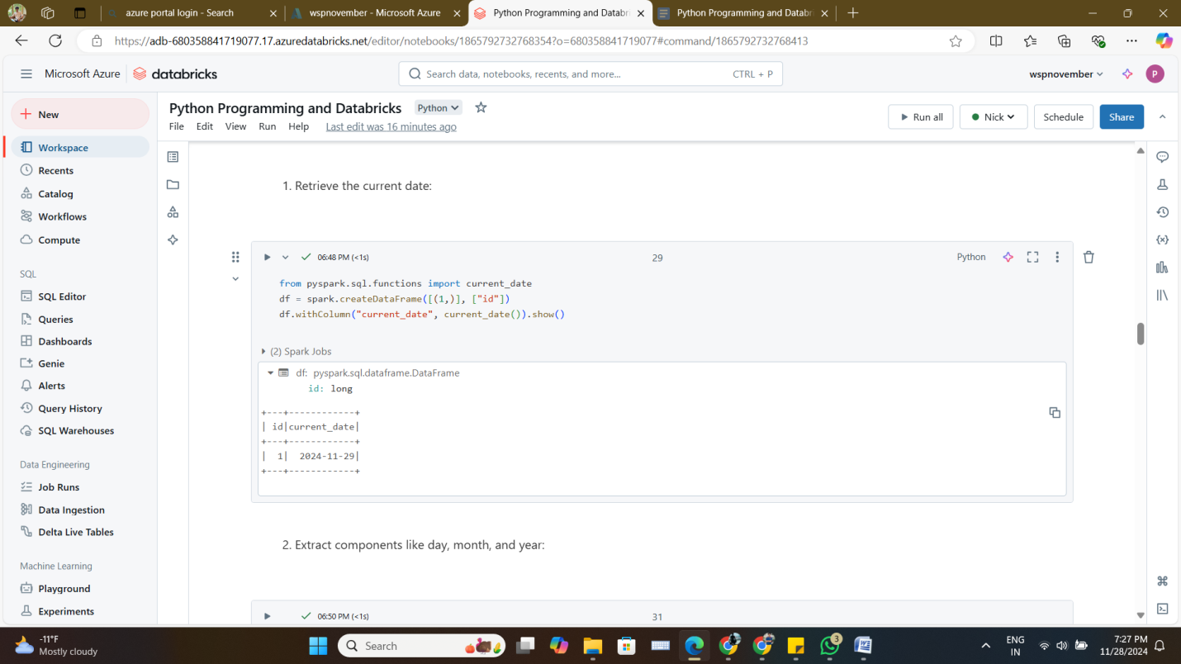

* + Extract components like day, month, and year from a date column.

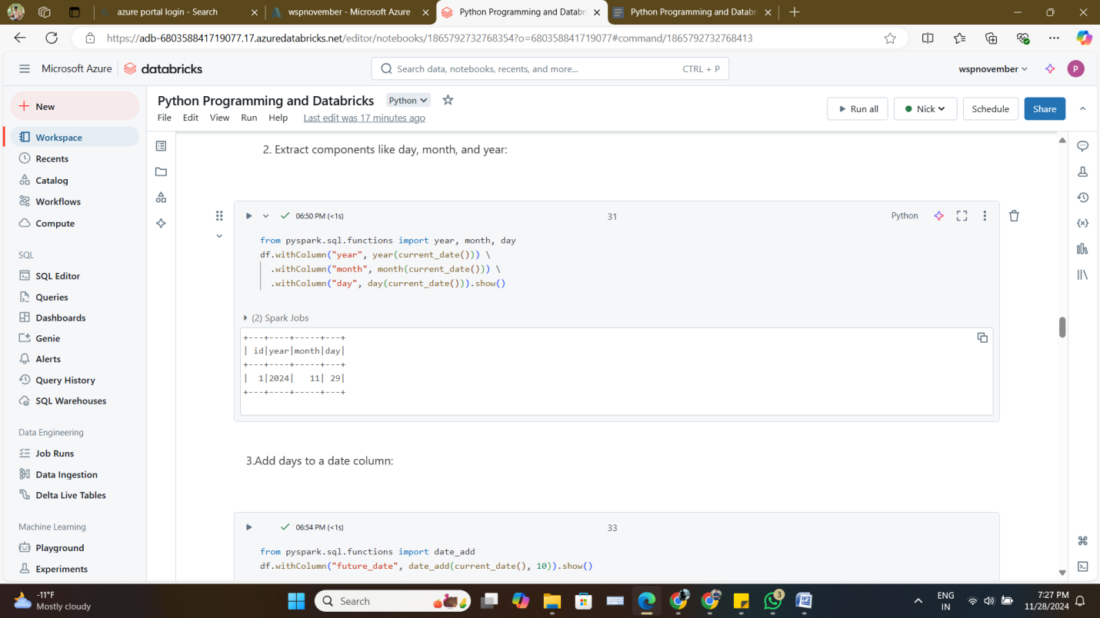

* + Add days to a date column and create a new column.

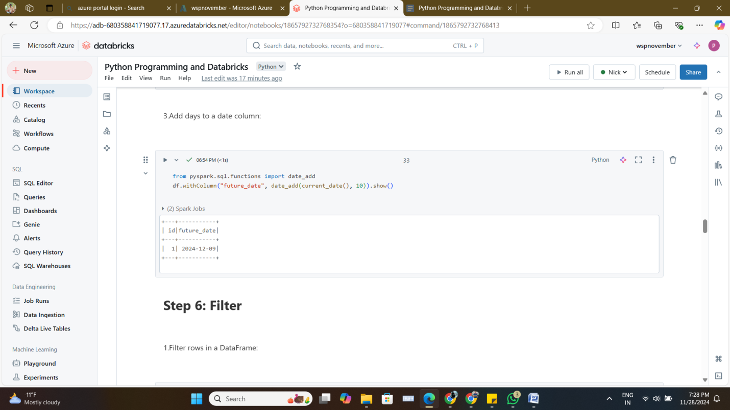

1. **Filter**
   * Filter rows in a DataFrame based on a single condition.

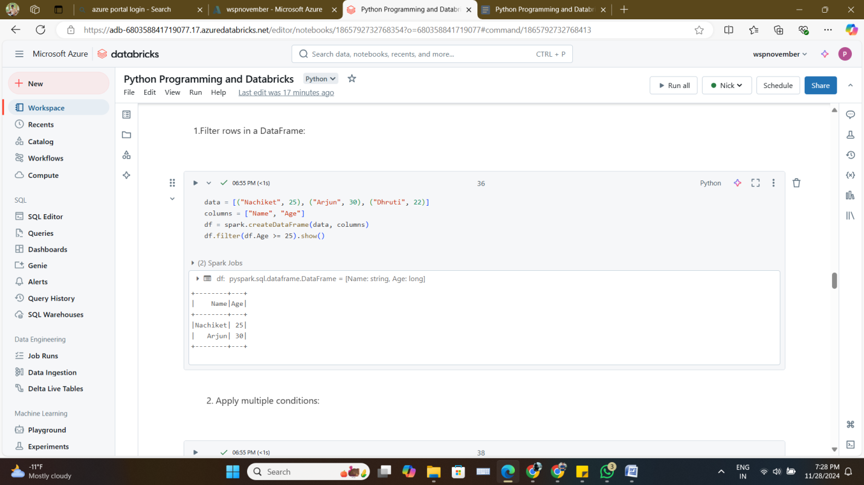

* + Apply multiple conditions to filter rows.

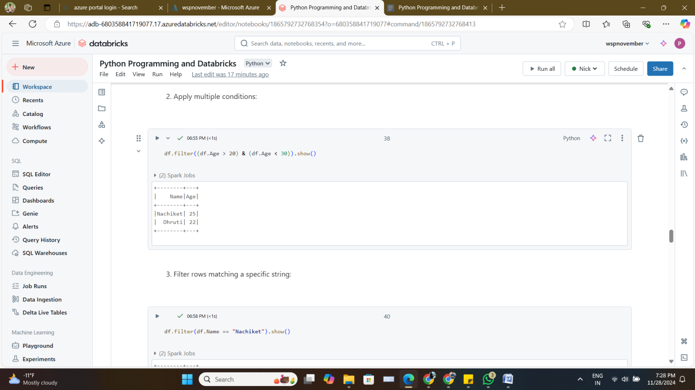

* + Filter rows matching a specific string value.

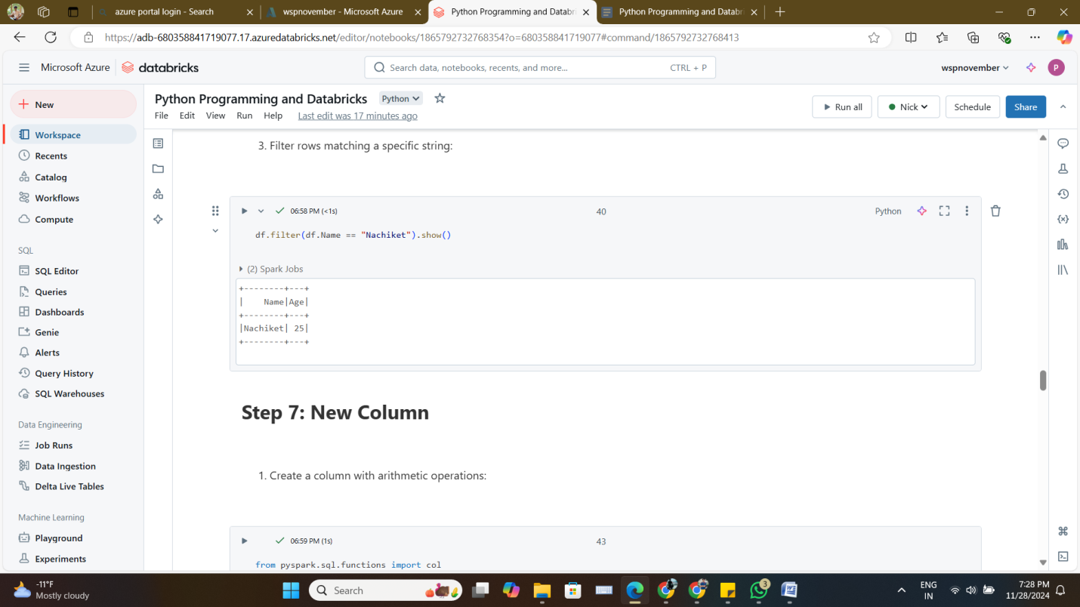

1. **New Column**
   * Create a column based on arithmetic operations.

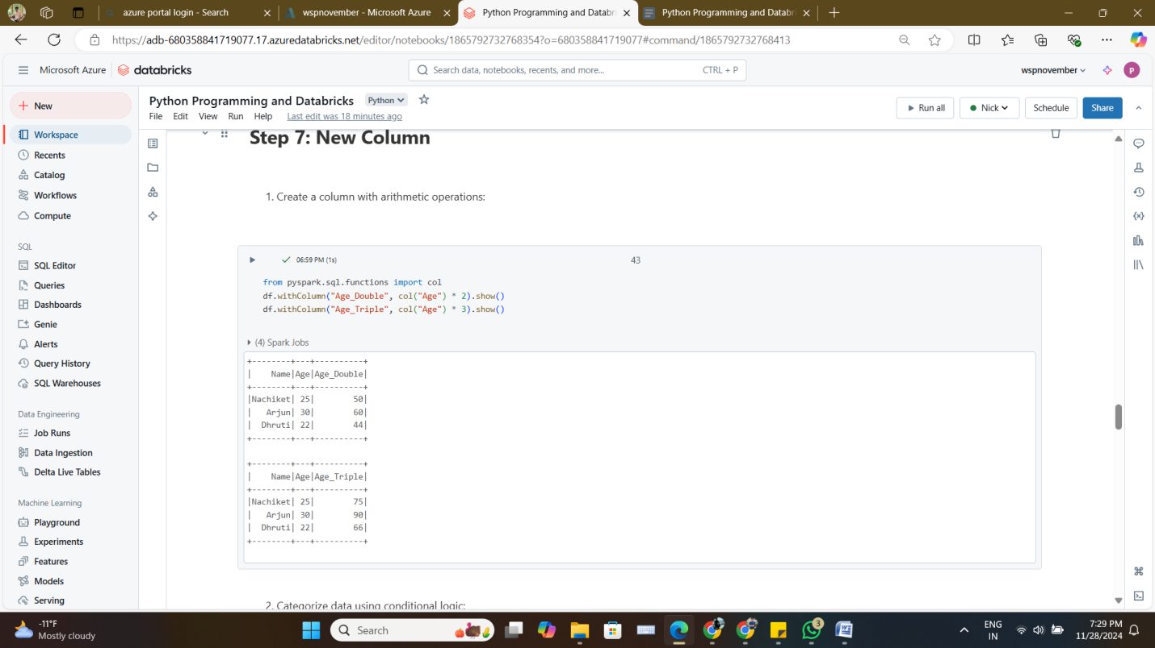

* + Categorize data into groups using conditional logic.

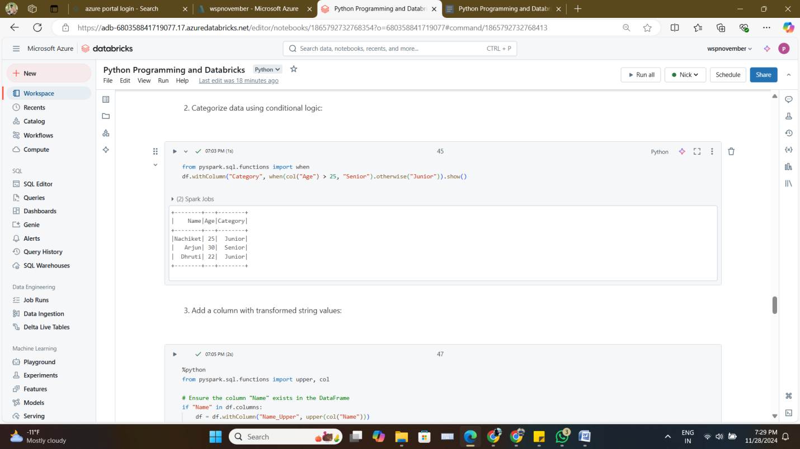

* + Add a column with transformed string values.

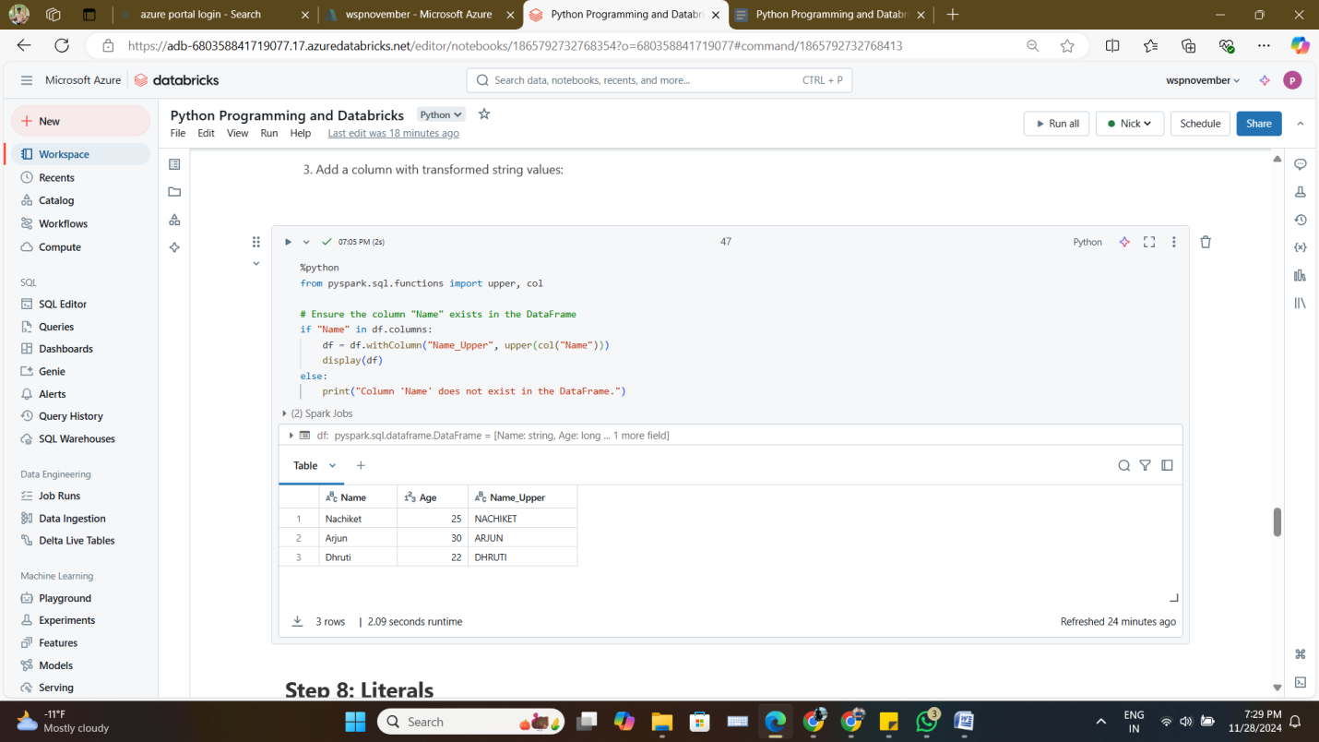

1. **Literals ('DATAFLOW')**
   * Create a DataFrame using a string literal.

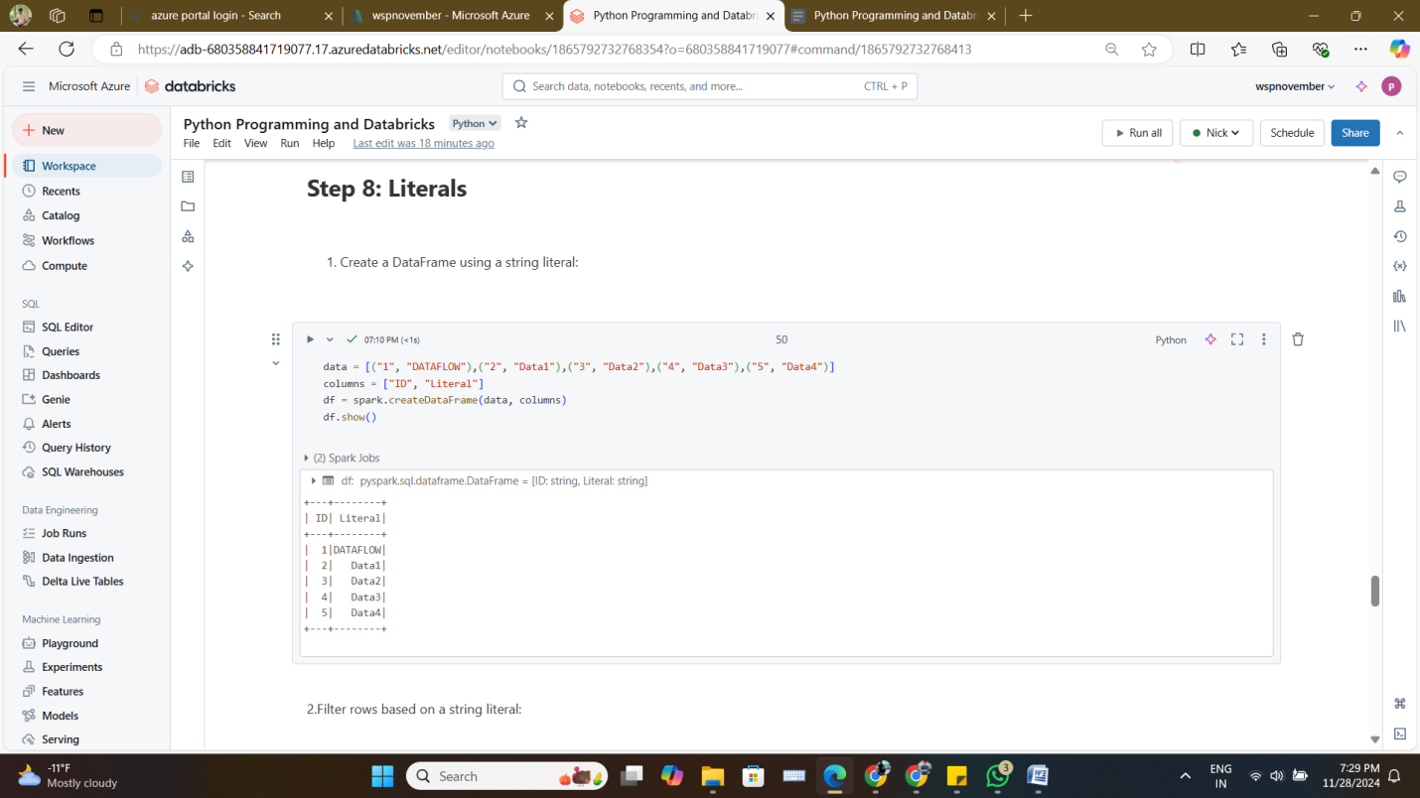

* + Filter rows based on a specific string literal.

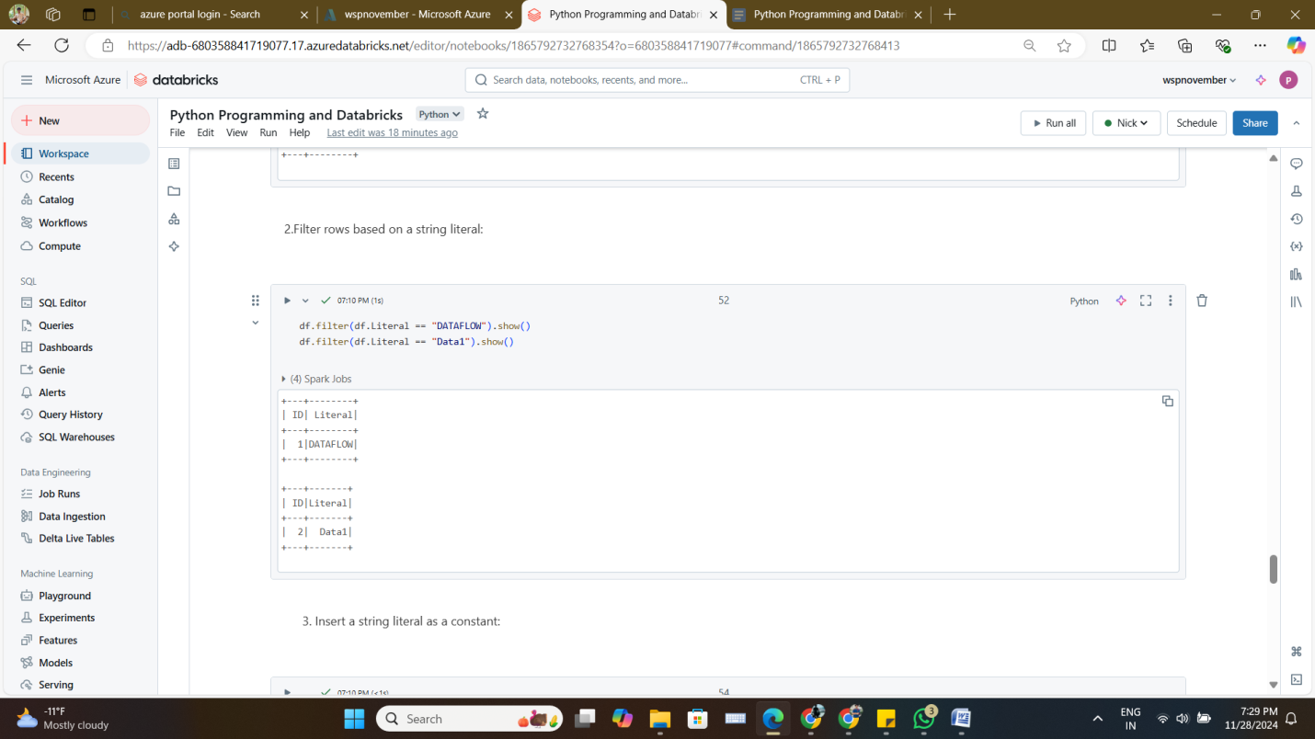

* + Insert a string literal as a constant value in a new column.

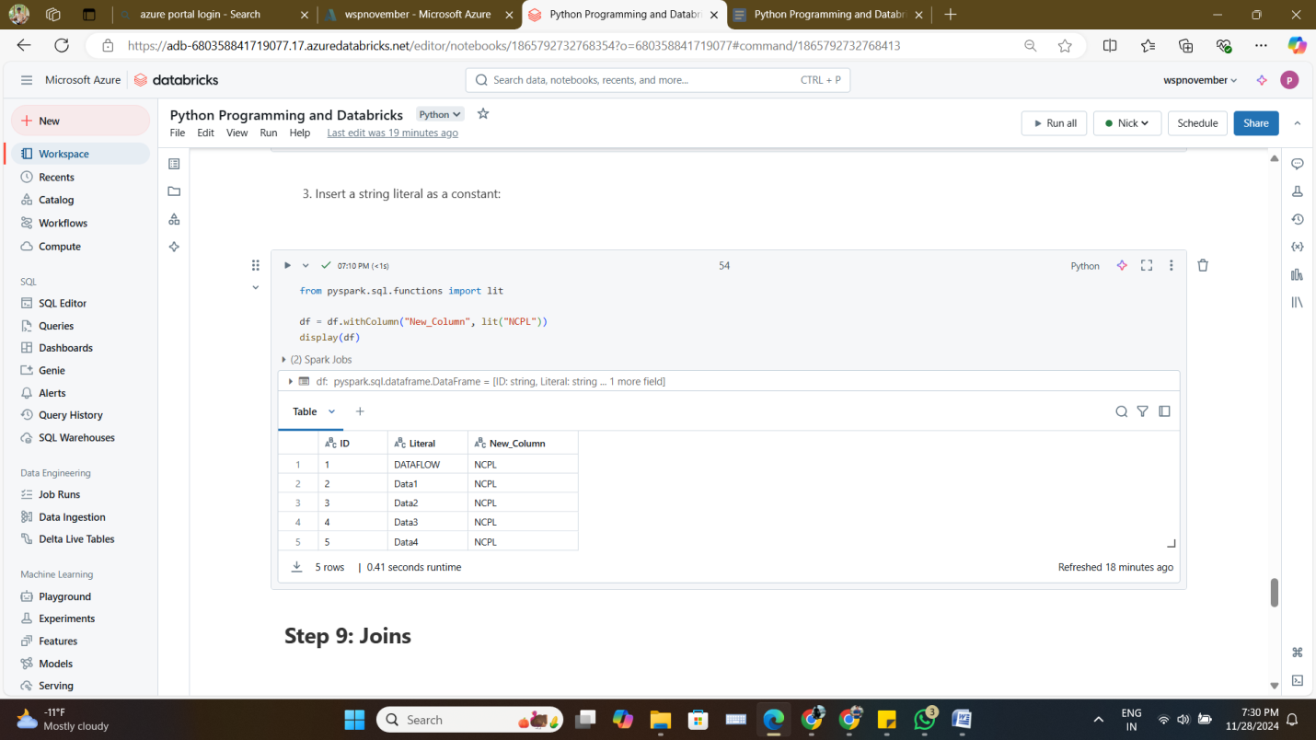

1. **Joins**
   * Perform inner, left, and full outer joins on DataFrames.

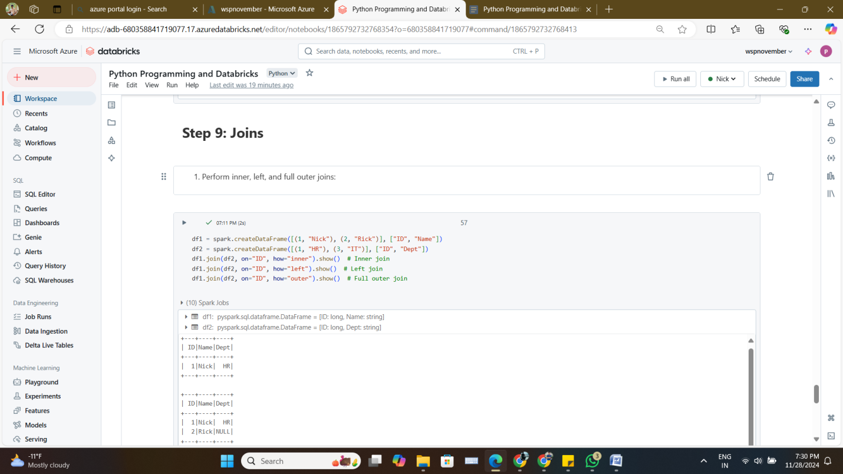

* + Merge DataFrames while handling null values.

